**Name: Maryam Mehreen**

**Sap Id: 35889**

**Lab : computer Networks**

**Q1: What is Ethernet cable? What type Ethernet cable is most commonly used in LAN network?**

**Solution:**

An Ethernet cable **'hardwires' your computer to an internet connection** An Ethernet cable, sometimes referred to as a network cable, is a cord that runs from a router, modem, or network switch to your computer, giving it internet access.

Ethernet Cables:

There are two types of Ethernet cables:

* **Cat6a** (Category 6a) is also becoming increasingly popular in environments where higher performance is needed, as it supports 10 Gbps speeds over the full 100-meter length of the cable and provides better shielding against interference.
* **Cat5e** (Category 5e) cables are still used in many networks due to their lower cost and adequate performance for most tasks, Cat6 and Cat6a are preferred for newer installations or upgrades, especially in environments requiring higher speeds and better performance.

**Q2: What is a LAN (local area network)? When and why to use LAN cable to send files from one computer to another?**

**Solution:**

**LAN(Local Area Network):**

A LAN, or Local Area Network, is a group of connected devices within a small area, like a home, office, or school. It allows these devices—such as computers, printers, and smartphones—to communicate with each other and share resources like files or an internet connection.

**Why use a LAN cable?**

You would use a LAN cable to send files from one computer to another when you want a fast and reliable connection between the two computers, usually within the same building or close area.

**When to use it:**

* When you need to transfer large files quickly.
* When you want a stable and reliable connection.
* When working in a setting where Wi-Fi might be unreliable or slow.

**Q3: How Does LAN Work? What is meant by 127.0.0.1 and localhost?**

**Solution:**

A Local Area Network (LAN) works by connecting multiple devices within a limited area, like a home, office, or school, so they can communicate and share resources

**What is meant by 127.0.0.1 and localhost?**

* **127.0.0.1** is a special IP address used to refer to your own computer on a network. It’s like saying "me" when you're talking to yourself.
* **localhost** is a name that means the same thing as 127.0.0.1. It’s a friendly way to refer to your computer in a network setting.

Q4: **How two computers can share files through disk sharing.?**

**Step 1:**

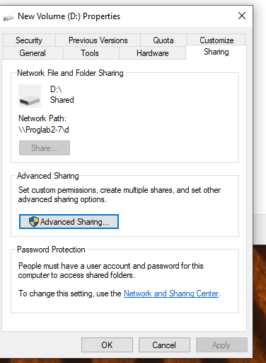

**Step 2:**

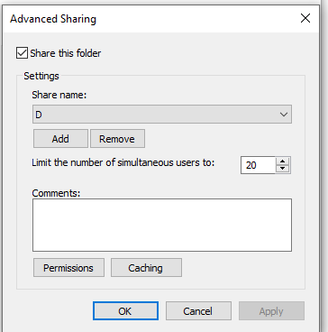

**Step3:**

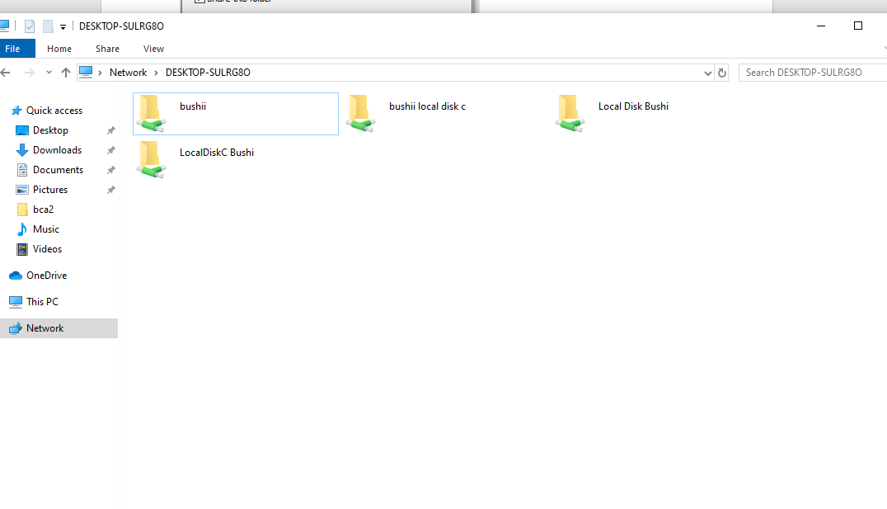

**STEP 4:**

